

Be One Personalize Care Own It! Improve Daily Innovate **AGENDA**

*The purpose of this agenda template is to intentionally incorporate our Culture work into   
our everyday work and processes, so we can accelerate progress on our Key Results.*

*This heading along with the italics within the template can be deleted. The purpose of the   
best practices and ideas noted in italics is to provide options to include embed* *Culture tools into our daily work.*

***Aim to have your agenda out to participants 24-48 hours in advance to enhance meeting engagement by allowing more preparation form all!***

GROUP/MEETING NAME

DATE / TIME

SITE / LOCATION

CALL IN INFORMATION

RECORDER

PARTICIPANTS

EXCUSED

| **Time** | **Key Result** | **Topic** | **Discussion Leader** |
| --- | --- | --- | --- |
| Start-end (minutes) |  | Reflection  *Options:*   * *Consider linking to our Values of Reverence, Integrity, Commitment to the Poor, Compassion, Excellence, Justice and Stewardship* * *There should be a "thread" of meaning from the opening prayer/reflection through the entire meeting. A prayer/reflection may also explicitly mention some of the business items on the agenda, and ask for guidance, wisdom, and clarity in decision-making based on Gospel values. Ideally, the prayer/reflection will connect with a theme or topic the team will discuss during their gathering.* * *Consider sharing the reflection with the meeting presenter(s) in advance. This preparation allows the meeting presenter(s) to think about how the reflection encourages the language in the reflection to be more universal so everyone feel included and valued. Our Mission and Core Values are based on principles embraced by most world religions as well as Catholic Social Teaching. When in doubt, a reflection leader can always turn to our Mission Statement and Core Values.* |  |
| 0:00-0:00  (3-5 minutes) | All | Focused Storytelling  *Tips:*   * *If storytelling is not natural yet, have someone prepare to share a story ahead of the meeting using the storytelling format.* * *Hand out the* [*focused storytelling template*](https://www.mercyone.org/assets/documents/mercyone_focused_storytellingjpg.jpg) *to provide support using the format until it becomes natural.* * *If stories are flowing, but do not include a Cultural Beliefs or are not linked to a Key Result after the story concludes say “that sounds like [Cultural Belief] to me and/or wow that will have a big impact on [insert Key Result). Thank you.*   *If appropriate, assign an owner to share stories with additional audiences.*  ***Share stories here!***  [*https://docs.google.com/forms/d/e/1FAIpQLSfO-BR1-wyi18uk0F_b7dj3QLLLyjn0y2g1rTBblX7z_myfvg/viewform?vc=0&c=0&w=1*](https://docs.google.com/forms/d/e/1FAIpQLSfO-BR1-wyi18uk0F_b7dj3QLLLyjn0y2g1rTBblX7z_myfvg/viewform?vc=0&c=0&w=1)  ***(OR)*** *if teams do not yet have solid connection to the Key Results,*  Key Result Practice/Linkage  *Options:*   * *Ask team members to pair up and list the Key Results or Cultural Beliefs.  (Offer prizes for teams who can list the Key Results).* * *Follow up with examples on how the group can affect one or more of the Key Results. Over several meetings, make sure to discuss the impact on each Key Result.* * *After people seem comfortable in pairs, ask for volunteers to share the full set.* * *Ask for volunteers to write each Key Result on your huddle board.* * *Ask for volunteers to share how they or their department have impacted a Key Result.* * *For meetings where participants already have a firm grasp of their impact on the Key Results, this section should be moved. Example: each business item could open with impact on the Key Results or have participants share 2 ways they impacted the Key Results as part of round robins/lightening rounds* |  |
| 0:00-0:00  (3 minutes) | All |  | All |
| 0:00-0:00  (# minutes) |  | Agenda topics linked to Key Results  Decision Maker: Name  *Consider for discussion:*   * *What beliefs are getting in our way?* * *What experiences must we create to shift beliefs?*   Document decision(s): Decision  Who needs to know about topics discussed? Names/Groups  Who owns communicating to these individuals/groups? Names  Review Next Steps/Assign Accountable Actions before moving to the next topic.  *Best practices to support:*   * *Refer to Steps to Alignment on Page 4 below to gain alignment in an efficient way and help support a smooth implement of change.* * *Assign tasks to individuals, not teams or functions.* * *Have a realistic deadline.* * *Hold your people accountable for their assignment.* * *Check-in along the way with those who have assignments.* * *Use the next meeting to get updates.* |  |
| 0:00-0:00  (3-15 minutes) |  | Focused Feedback  *Best practices:*   * *Ask, “What feedback did you receive this week that you found valuable and what are you doing to act on it?”* * *On a regular basis say “I plan to put us into pairs and do focused feedback with each other. I’ll let you know who my partner will be and I’ll ask you to get a partner and we’ll take the first/last 10-15 minutes of the meeting to give and receive feedback.”* * *Ask,* *“What feedback do you have for me regarding [something specific about the meeting]?”* * *Say “thank you” for all feedback. Remember beliefs are not right or wrong. Consider how to create experiences that change the beliefs.* * *Encourage both positive and constructive feedback.*   **(OR)**  Focused Recognition  *Options:*   * *Ask how many Focused Recognition cards every person in the meeting has given since the last meeting. Set a goal for the next meeting.*   *Set aside time for the meeting participants to write cards and have other sign them to show appreciation.* |  |

**Our Mission**

MercyOne serves with fidelity to the Gospel as a compassionate, healing ministry of Jesus Christ to transform the health of our communities.

**Our Vision**

MercyOne will set the standard for a personalized and radically convenient system of health services.

**Our Values**

Integrity, Commitment to the Poor, Compassion, Excellence, Justice, Stewardship, Reverence

|  |  |  |  |  |
| --- | --- | --- | --- | --- |
| **MercyOne Key Results** | | | | |
| **Consumer Experience**  **"Would Recommend" at the 75th Percentile by 2021** | **Team Engagement**  **Overall Engagement at the 75th Percentile by 2021** | **Quality**  **All cause unplanned 30-day readmission rate 13.8%** | **Financial Performance**  **Operating Margin 3.5%** | **Ambulatory Growth**  **3.4 million non inpatient encounters generating revenue** |

**FOCUSED STORYTELLING FORMAT**

*“Here’s what (Cultural Belief) looks like to me.”*

Story should be told in under 45 seconds and include the impact on *Key Results*.

End with, *“That’s what (Cultural Belief) looks like to me.”*

**Example:** *“Here’s what Being One looks like to me. Participants in the emergency department affinity group have agreed to come together from around the state to learn from each other to improve our Consumer Experience Key Result. That’s what Being One looks like to me.”*

**Meeting best practices**

Take the **Leadership Alignment Process** learned during culture workshops into account when considering meeting participants and craft the discussion flow and next steps. We learned “when all the parts are aligned and everyone is moving in the same direction, you get accelerated culture change; everyone stays on the same page, people feel less stressed, decision making occurs more efficiently and almost everything speeds up.” Following these steps helps gain alignment in an efficient way, and helps support smooth implementation of changes because the people impacted by a change feel heard and everyone is on the same page.

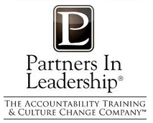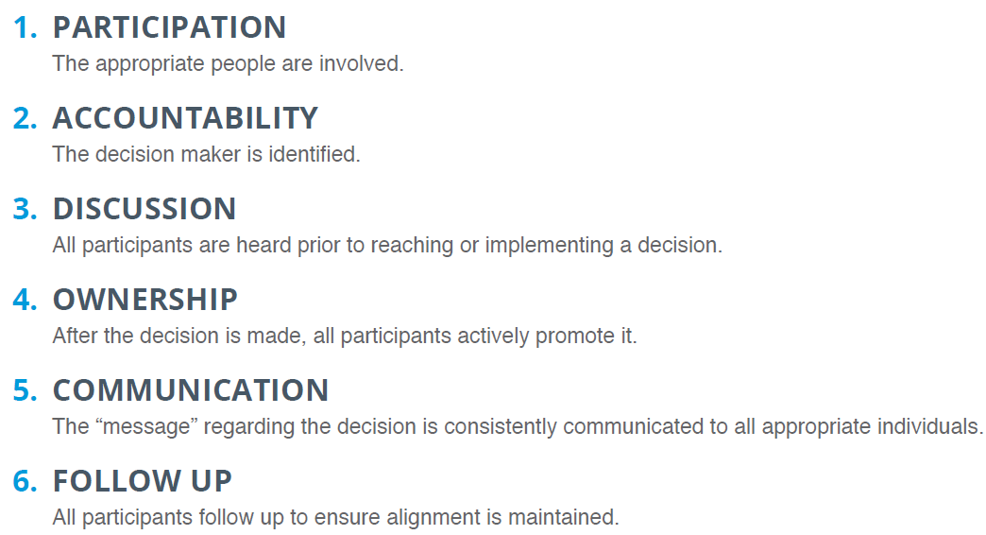

*Licensed for use by supervisors, managers, directors and executive team members.*

Watch for signs of lack of alignment such as:

* People remaining silent and not voicing their opinion when it is time to call for a decision; leaders and teams
* Are surprised by the actions people take because they are inconsistent with the agreed-upon direction
* There isn’t tangible progress on an issue when things should be moving forward
* People keep bringing up issues you thought were resolved
* People complain, make excuses, and blame others for lack of progress
* There is a lack of ownership and enthusiasm for implementing an established course of action
* People voice disagreement with a decision or a direction which has already been taken

*Source: Change the Culture Change the Game, Roger Connors and Tom Smith.*

**The following are some of the questions you should ask yourself as you prepare your agenda:**

* What am I trying to accomplish?
* What information do I need to make a decision?
* Have I invited the right people to attend?
* Is this meeting even necessary?
* Am I trying to do too much?

**During the meeting document clearly document specific follow ups, individual owners and due dates.   
This template building on what we learned about how to stay above the line can be a helpful tool.**

|  |  |  |  |
| --- | --- | --- | --- |
| **See It** | **Own It** | **Solve It** | **Do It** |
| What is the problem? What is the reality I/We need to acknowledge the most? | How am I/We contributing to the problem and/or solution? What beliefs do we need to change? | What Else Can I do?  Fill this in as action steps are defined. Remember to consider experiences needed to change beliefs. | Who is accountable to do what and by when? |



**MEETING MINUTES**

***Aim to have your minutes out to participants 24-48 hours after the meeting and include follow up on the who, what, when***

***to enhance meeting outcomes through task completion!***

GROUP/MEETING NAME

DATE / TIME

SITE / LOCATION

CALL IN INFORMATION

RECORDER

PARTICIPANTS

EXCUSED

|  |  |  |  |  |  |
| --- | --- | --- | --- | --- | --- |
| **ITEM** | **DISCUSSION** | **NEXT STEPS** | **RESPONSIBLE PARTY** | | **DUE DATE** |
|  |  |  |  | |  |
|  |  |  |  | |  |
|  |  |  |  | |  |
|  |  |  |  | |  |
|  |  |  |  | |  |
|  |  |  |  | |  |
|  |  |  |  | |  |
|  |  |  |  | |  |
|  |  |  |  |  | | |
|  |  |  |  |  | | |
|  |  |  |  |  | | |
|  |  |  |  |  | | |
|  |  |  |  |  | | |
|  |  |  |  |  | | |

**Our Mission**

MercyOne serves with fidelity to the Gospel as a compassionate, healing ministry of Jesus Christ to transform the health of our communities.

**Our Vision**

MercyOne will set the standard for a personalized and radically convenient system of health services.

**Our Values**

Integrity, Commitment to the Poor, Compassion, Excellence, Justice, Stewardship, Reverence

|  |  |  |  |  |
| --- | --- | --- | --- | --- |
| **MercyOne Key Results** | | | | |
| **Consumer Experience**  **"Would Recommend" at the 75th Percentile by 2021** | **Team Engagement**  **Overall Engagement at the 75th Percentile by 2021** | **Quality**  **All cause unplanned 30-day readmission rate 13.8%** | **Financial Performance**  **Operating Margin 3.5%** | **Ambulatory Growth**  **3.4 million non inpatient encounters generating revenue** |